3.15.x Final Assignment

Part 1
Q1
R: Shape: (22770, 8) (22770 rows and 8 columns)

Q2
R: There are 11 unique jobs roles.

Q3
There are 102 unique job titles for Python Job Role, assuming the data as it is.
R: There are 72 unique job titles for Python Job Role, after cleaning data as shown above in the code.

Q4
R: The number of companies that have a python job role with a job title containing the substring Analyst is 3.

Q5
R: The Company which has the highest number of Salaries reported is Amazon (Total of 2636 salaries).

Q6
R: Amazon is present in 9 locations.

Q7
R: At the moment the conversion rate between USD-INR is 83.12.

Q8
R: The average Salary USD for the Python Job Role is 5847.35

Q9
R: The Company which has the highest Salary USD is Thapar University.

Q10
R: The company which is causing this oddity is Thapar University.

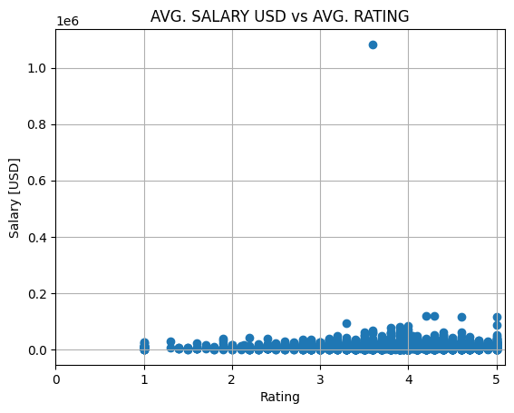
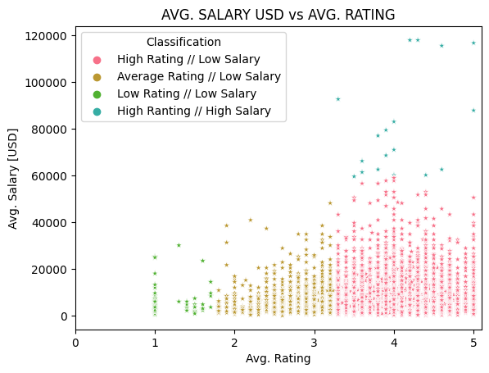

Part 2

Q1
R: Shape: (2343, 10) (2343 rows and 10 columns)

Q2
R: The total amount of funding was 271,558,456,804 $.

Q3
R: The rank of Inflection Point Ventures was 4th.

Q4
R: The city that received the highest Avg. Rating was Kolkata which founded 5 companies.

Q5
R: The city that stands out in terms of total funding received by companies and salary paid was Mumbai.
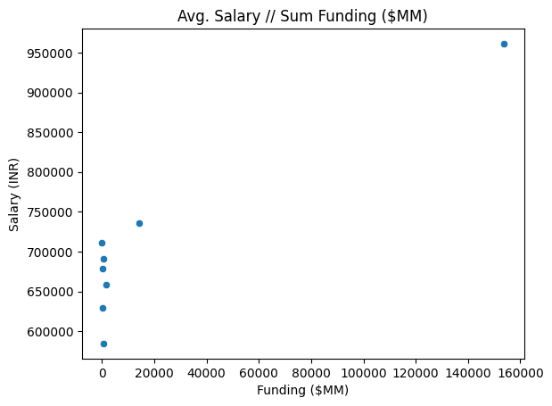

Q6
1 - R: The city with the highest literacy level (98.36) in the country is Aizawl.
2 - R: The missing city is New Delhi.
3 - R: From my results, I don't see a strong relation between the variables Literacy and Average Salary. Jaipur, Kolkata, Bangalore and Mumbai seem to fit on a positive relation between the two variables. However, the other variables seem to be out of this trend, especially Chennai, where the literacy is high (actually the highest) and the average salary is the lowest.

